**Day 2   
Madhu kalyani Gadi (05-12-2023)**

**MySQL commands Hands-On:**

Firstly,creating a database called pet_adoption to store all the details of animals and their adoptions.

CREATE Database pet_adoption;

Creating animals table with required attributes.

CREATE TABLE animals ( id UNIQUEIDENTIFIER NOT NULL, name NVARCHAR(255), breed NVARCHAR(255), color NVARCHAR(255), gender NVARCHAR(255), status INT);

To record adoption transactions we have the attributes id, name and contact of the person who adopted the animal in the adoptions table.

CREATE TABLE adoptions ( animal_id UNIQUEIDENTIFIER NOT NULL, name NVARCHAR(MAX), contact NVARCHAR(MAX), date DATETIME);

To check whether the tables are created, I have used the following command.

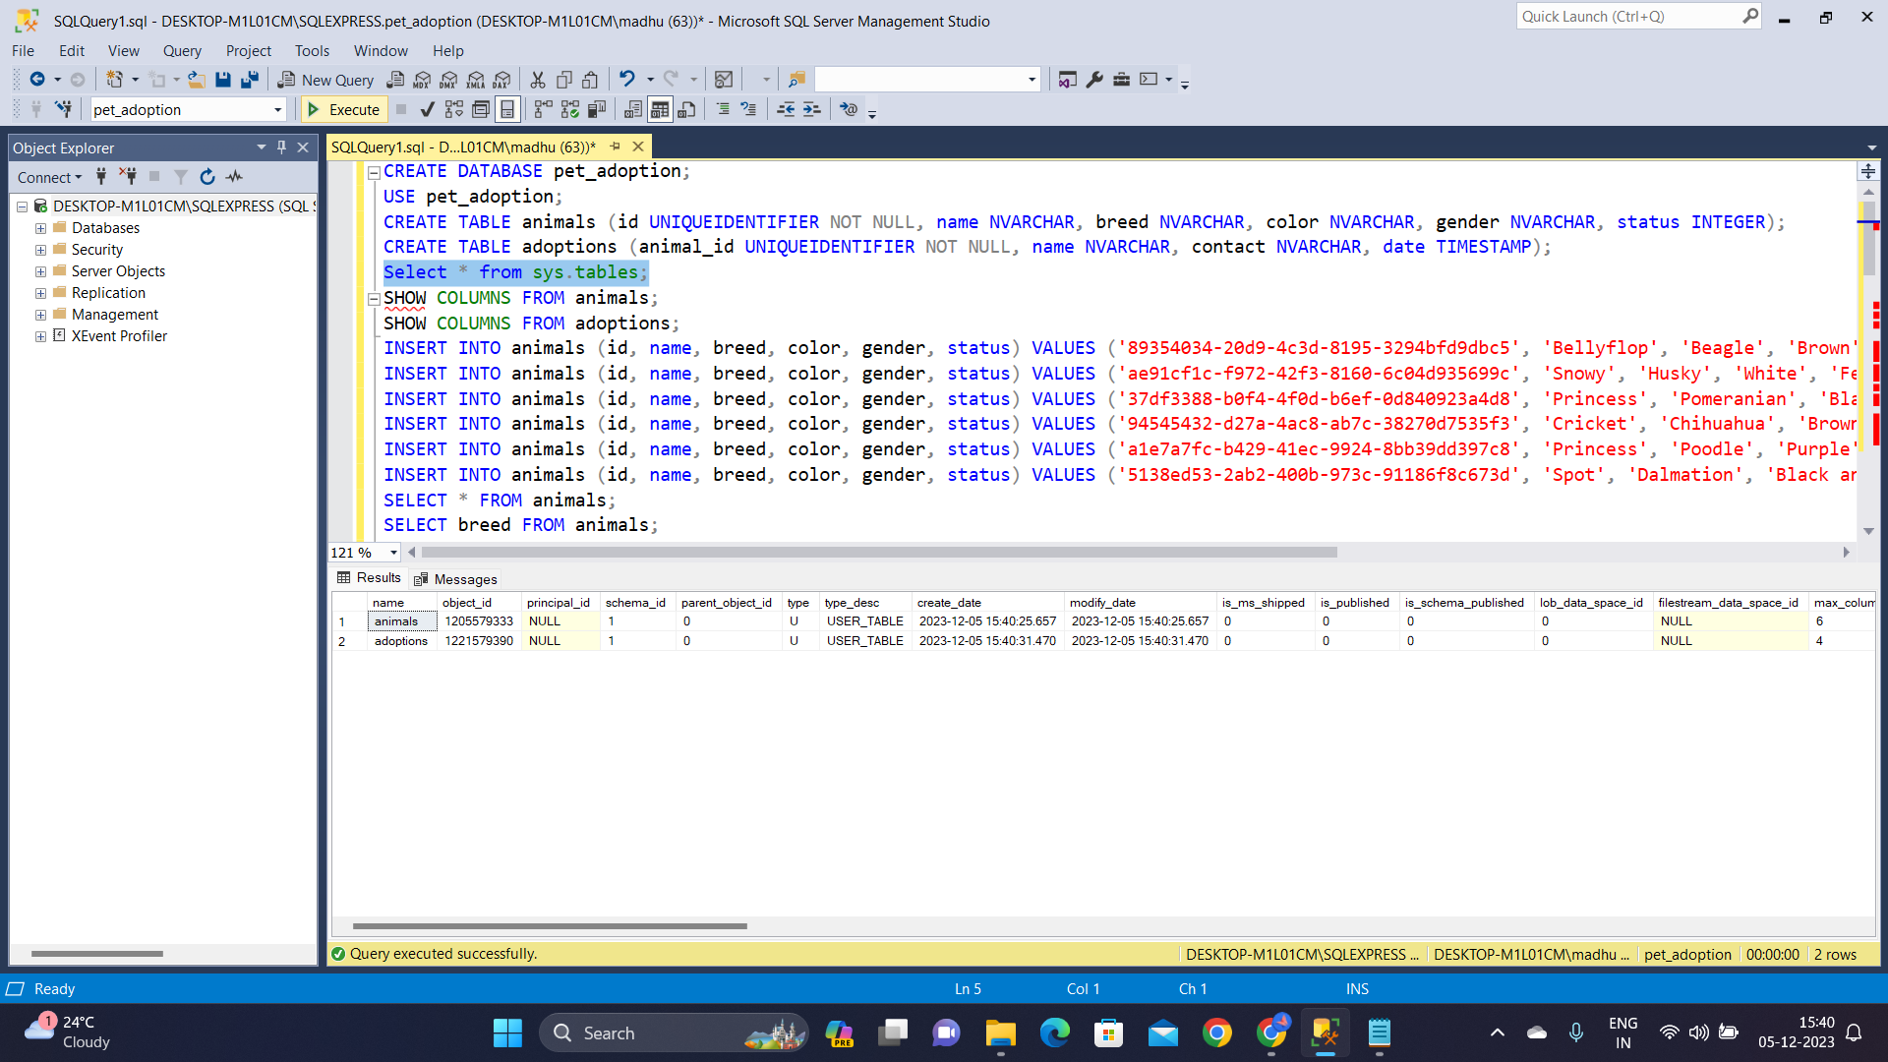

To check all the columns of animals and adoptions table, the below commands are used: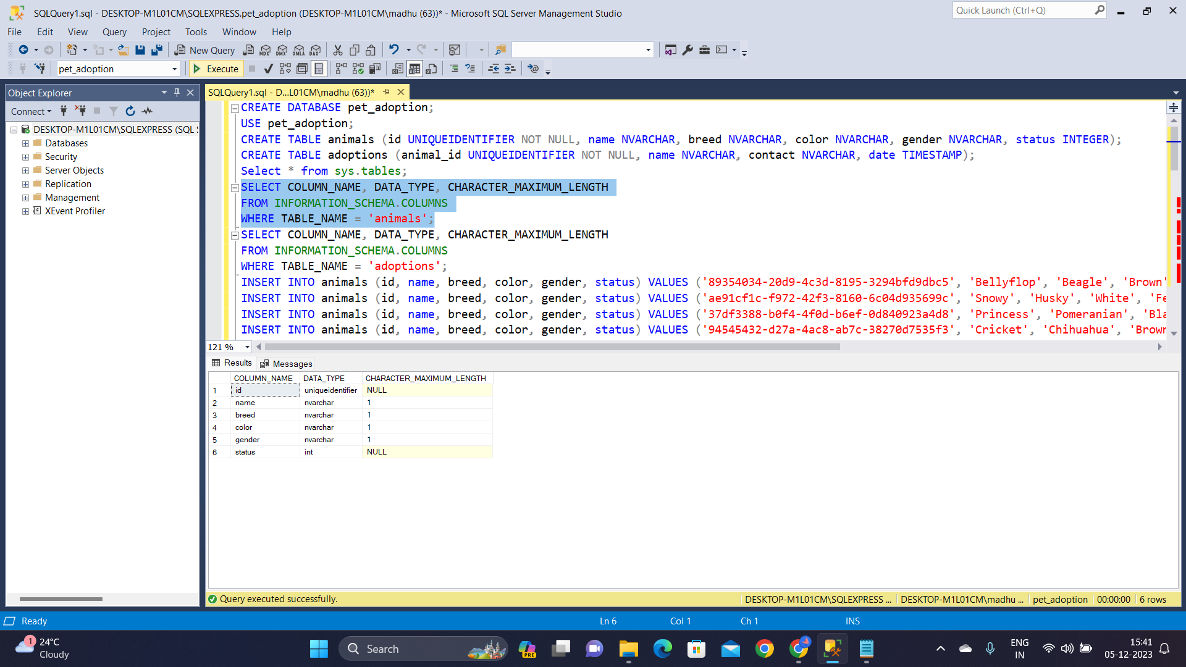

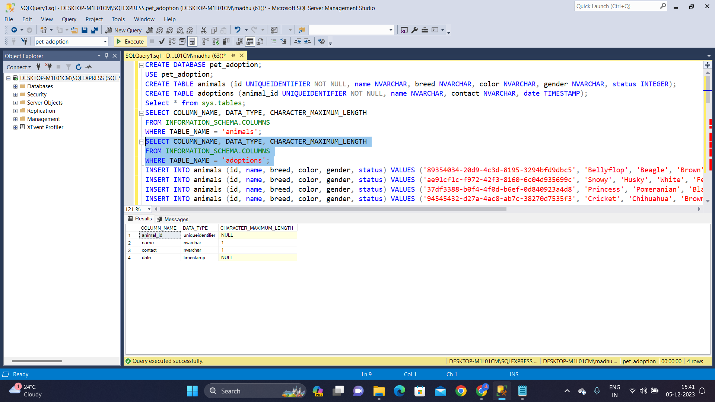

To insert the values of dogs into the animals table:  
INSERT INTO animals (id, name, breed, color, gender, status) VALUES  
('89354034-20d9-4c3d-8195-3294bfd9dbc5', 'Bellyflop', 'Beagle', 'Brown', 'Male', 0);

INSERT INTO animals (id, name, breed, color, gender, status) VALUES ('89354034-20d9-4c3d-8195-3294bfd9dbc5', 'Bellyflop', 'Beagle', 'Brown', 'Male', 0);

INSERT INTO animals (id, name, breed, color, gender, status) VALUES ('ae91cf1c-f972-42f3-8160-6c04d935699c', 'Snowy', 'Husky', 'White', 'Female', 0);

INSERT INTO animals (id, name, breed, color, gender, status) VALUES ('37df3388-b0f4-4f0d-b6ef-0d840923a4d8', 'Princess', 'Pomeranian', 'Black', 'Female', 0);

INSERT INTO animals (id, name, breed, color, gender, status) VALUES ('94545432-d27a-4ac8-ab7c-38270d7535f3', 'Cricket', 'Chihuahua', 'Brown', 'Male', 0);

INSERT INTO animals (id, name, breed, color, gender, status) VALUES ('a1e7a7fc-b429-41ec-9924-8bb39dd397c8', 'Princess', 'Poodle', 'Purple', 'Female', 0);

Using **insert** command, few values are inserted into the animals table, we can display the table by using **select** command:

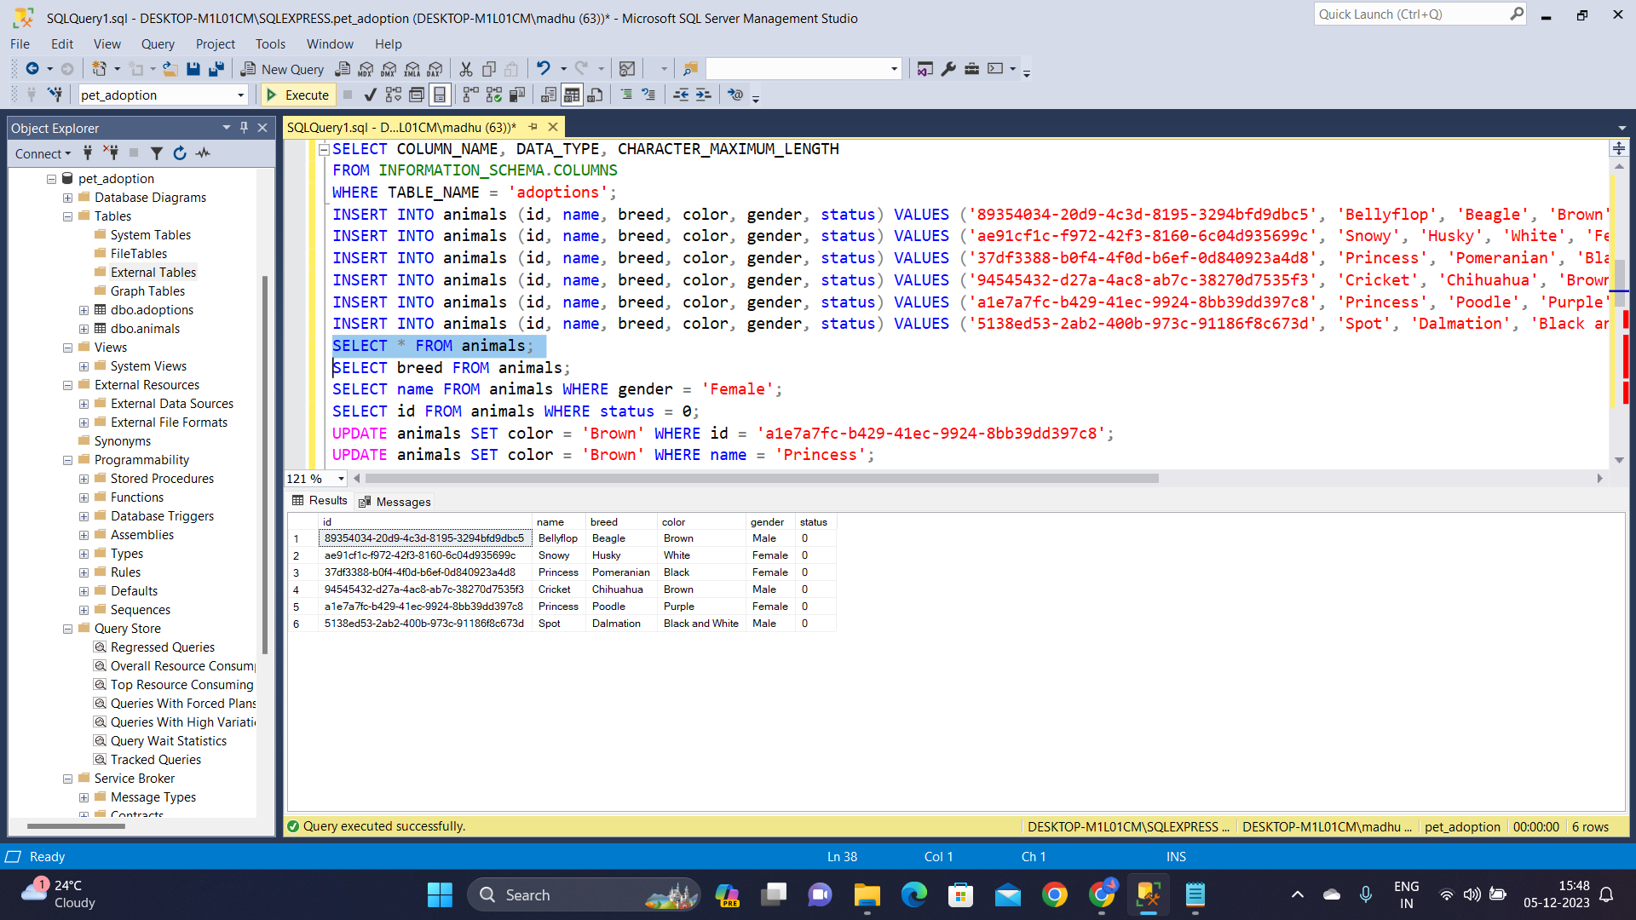

To display all the breeds in the animals table, the **select** command is used below.

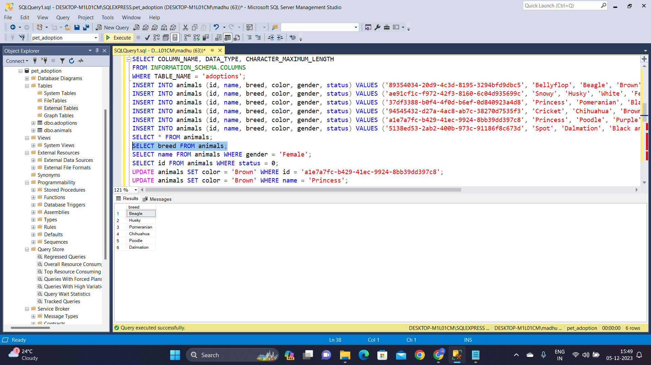

Displaying the animals having gender as female and by using **select** command:

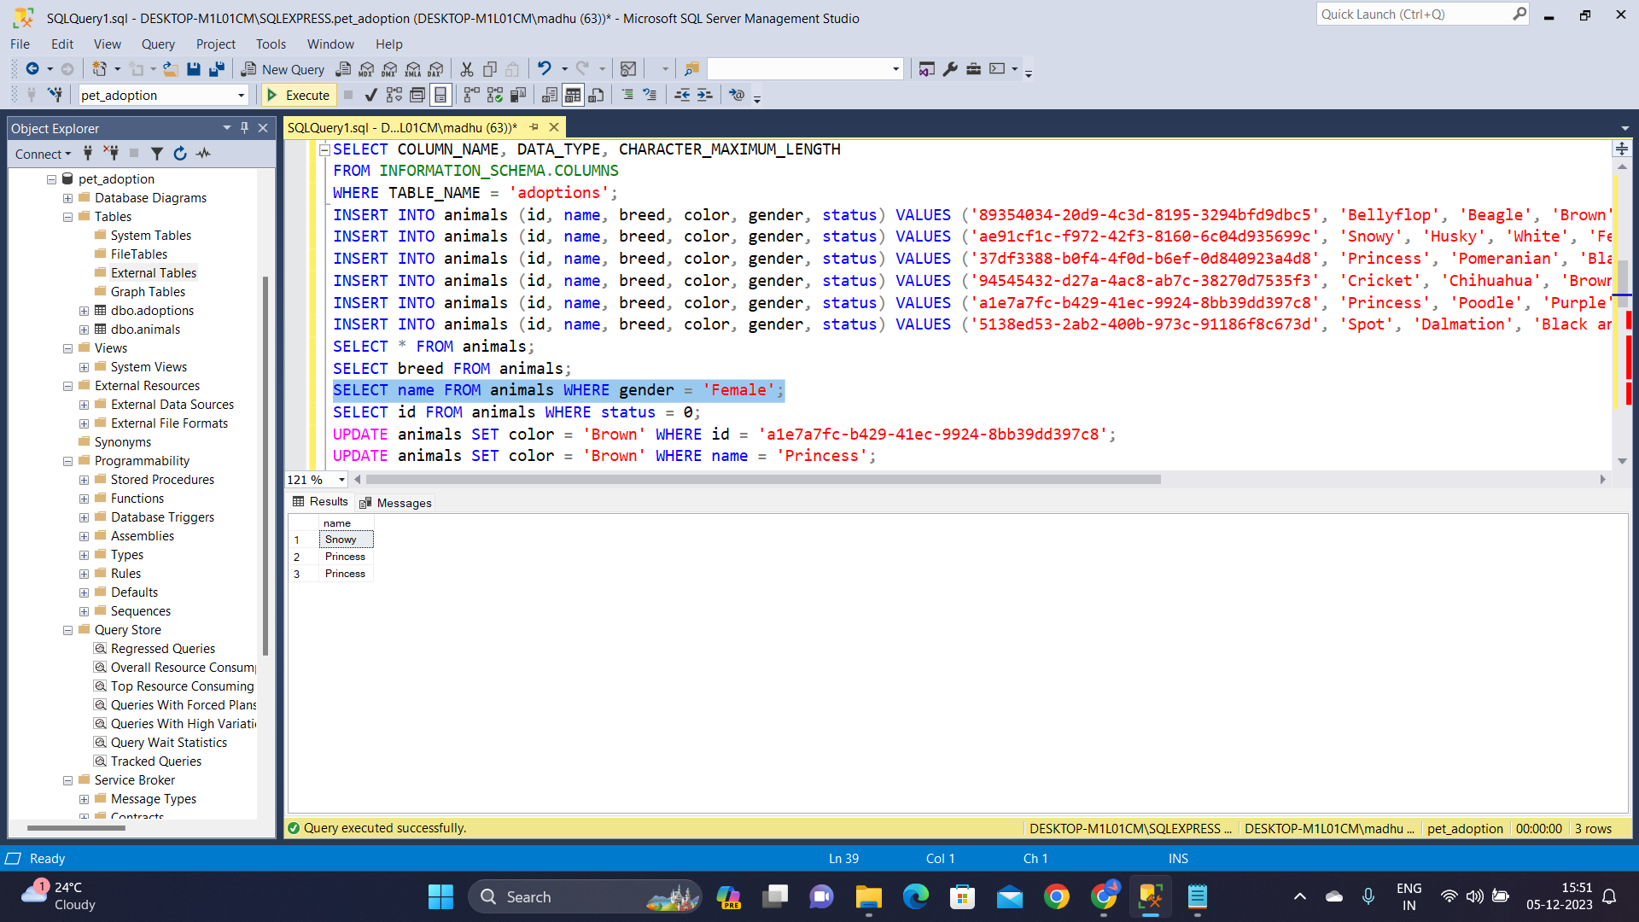

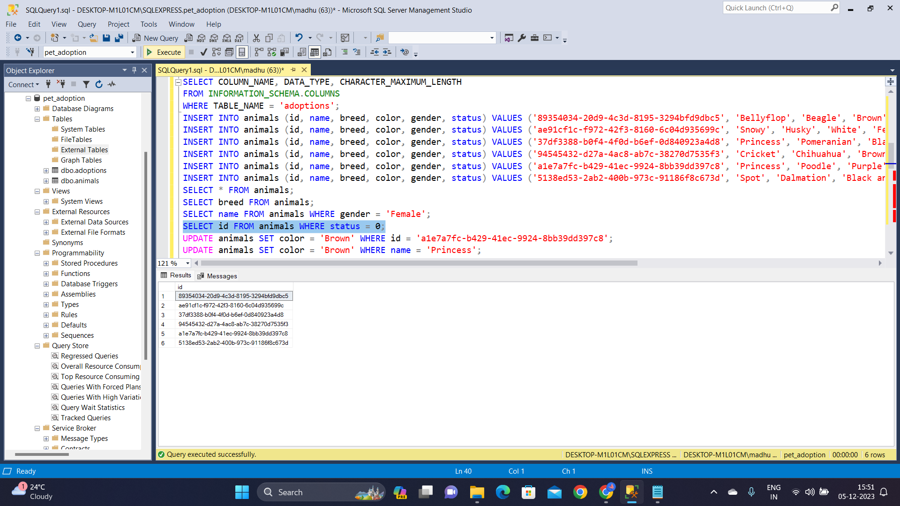

Updating the values of few animals by using **update** and **where** clauses:

For eg:

Sets the 'color' column of the 'animals' table to 'Brown' for the row where the 'id' is 'a1e7a7fc-b429-41ec-9924-8bb39dd397c8'. The specified animal's color is changed to 'Brown'.

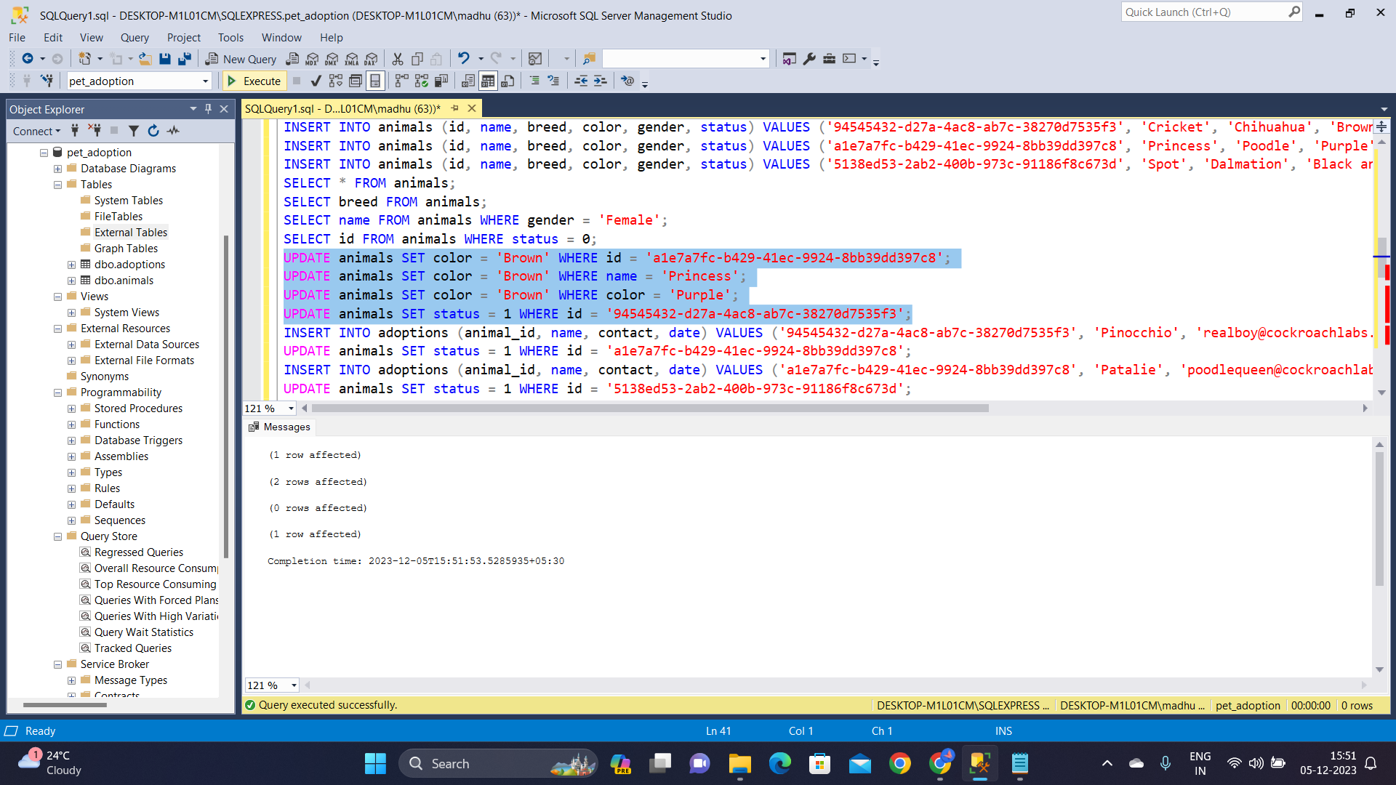

By using **select** command displaying the adoptions table after inserting few values in adoption table:

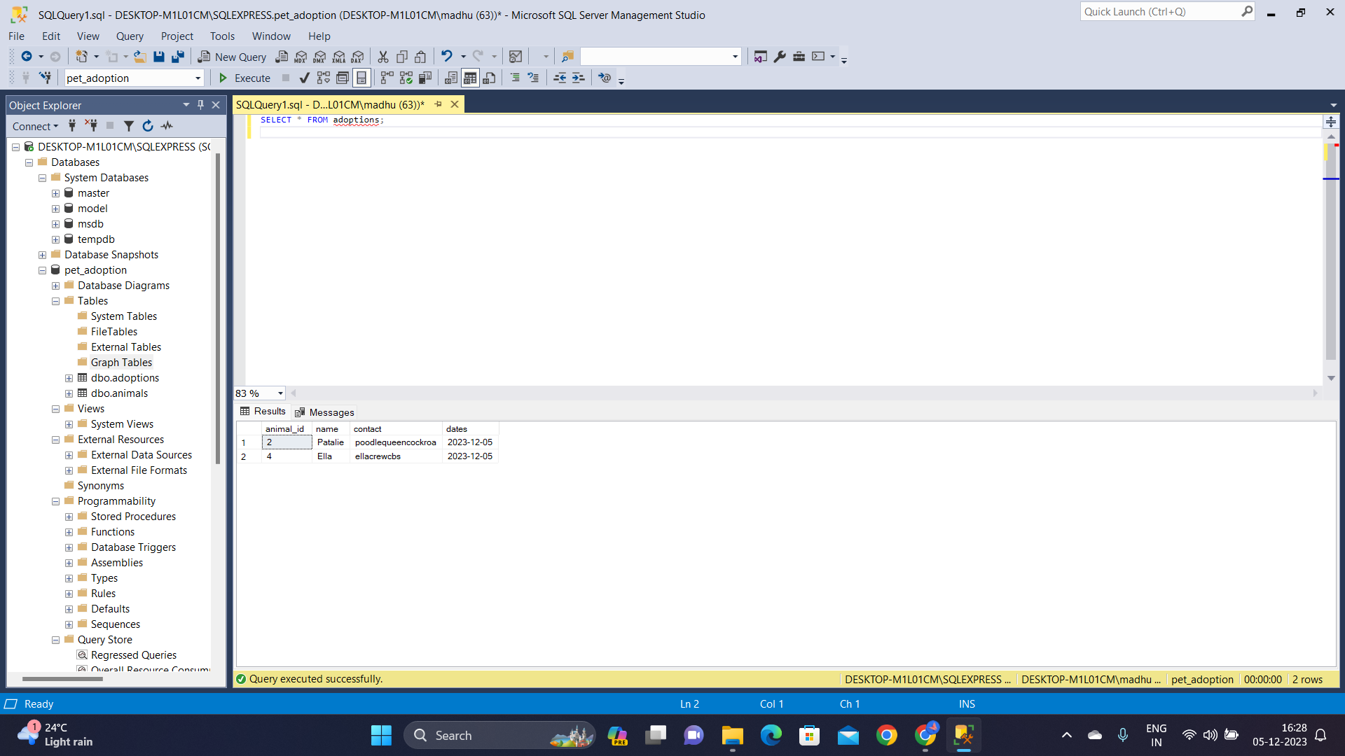

To sort the transactions of adoptions according to the date of adoption **Order By** command is used followed by ascending/descending order.

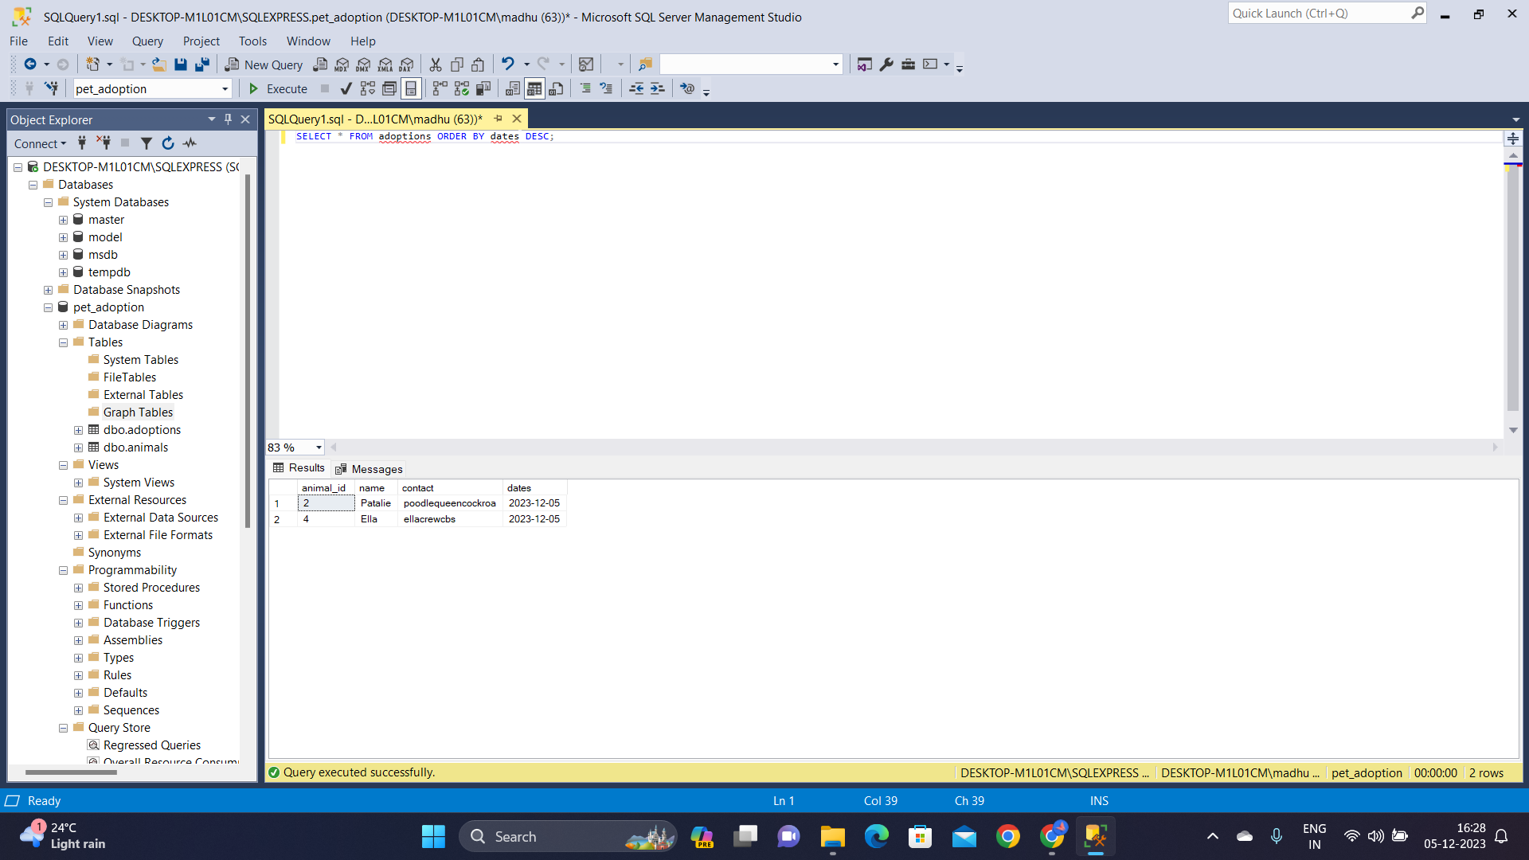

To check the animals which are adopted by checking if their status is 1 by using both **select** and **where** commands:

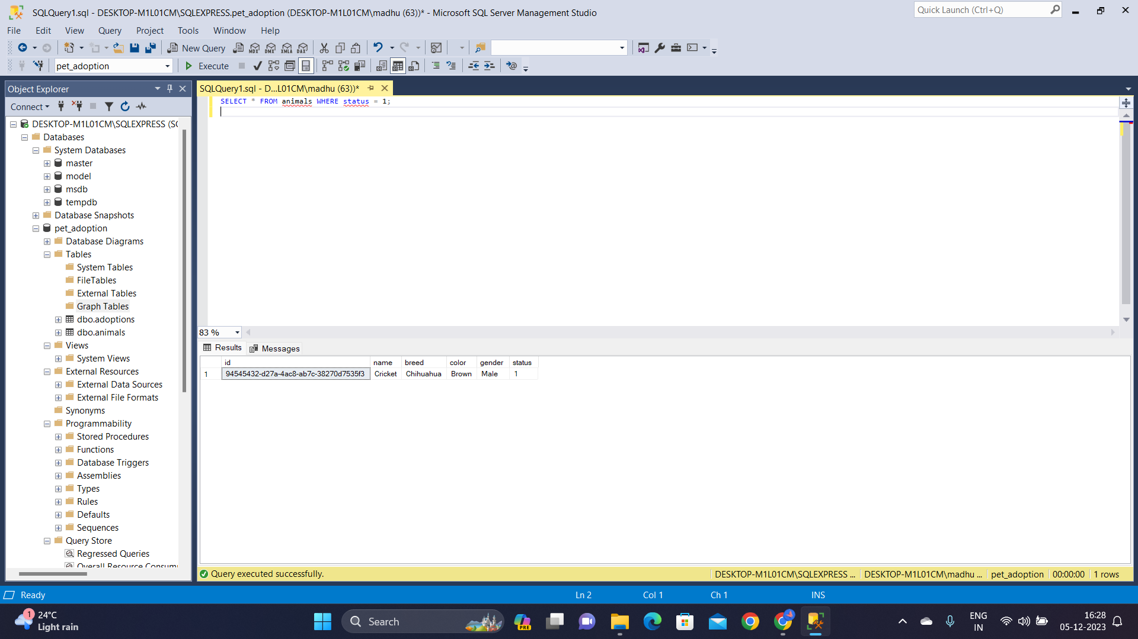

To add other animals like cat etc into the animals table, species column is added to the animals table by using **add** and **alter** commands to keep track of the species.

ALTER TABLE animals  
ADD species NVARCHAR(MAX);  
  
Then update all the previously inserted records as “Dog” species.

UPDATE animals SET species=’Dog’;

After that, inserted the details of shelters in the shelters table where the animals can be adopted among various locations. After inserting few values, displayed it bys using **select** command:

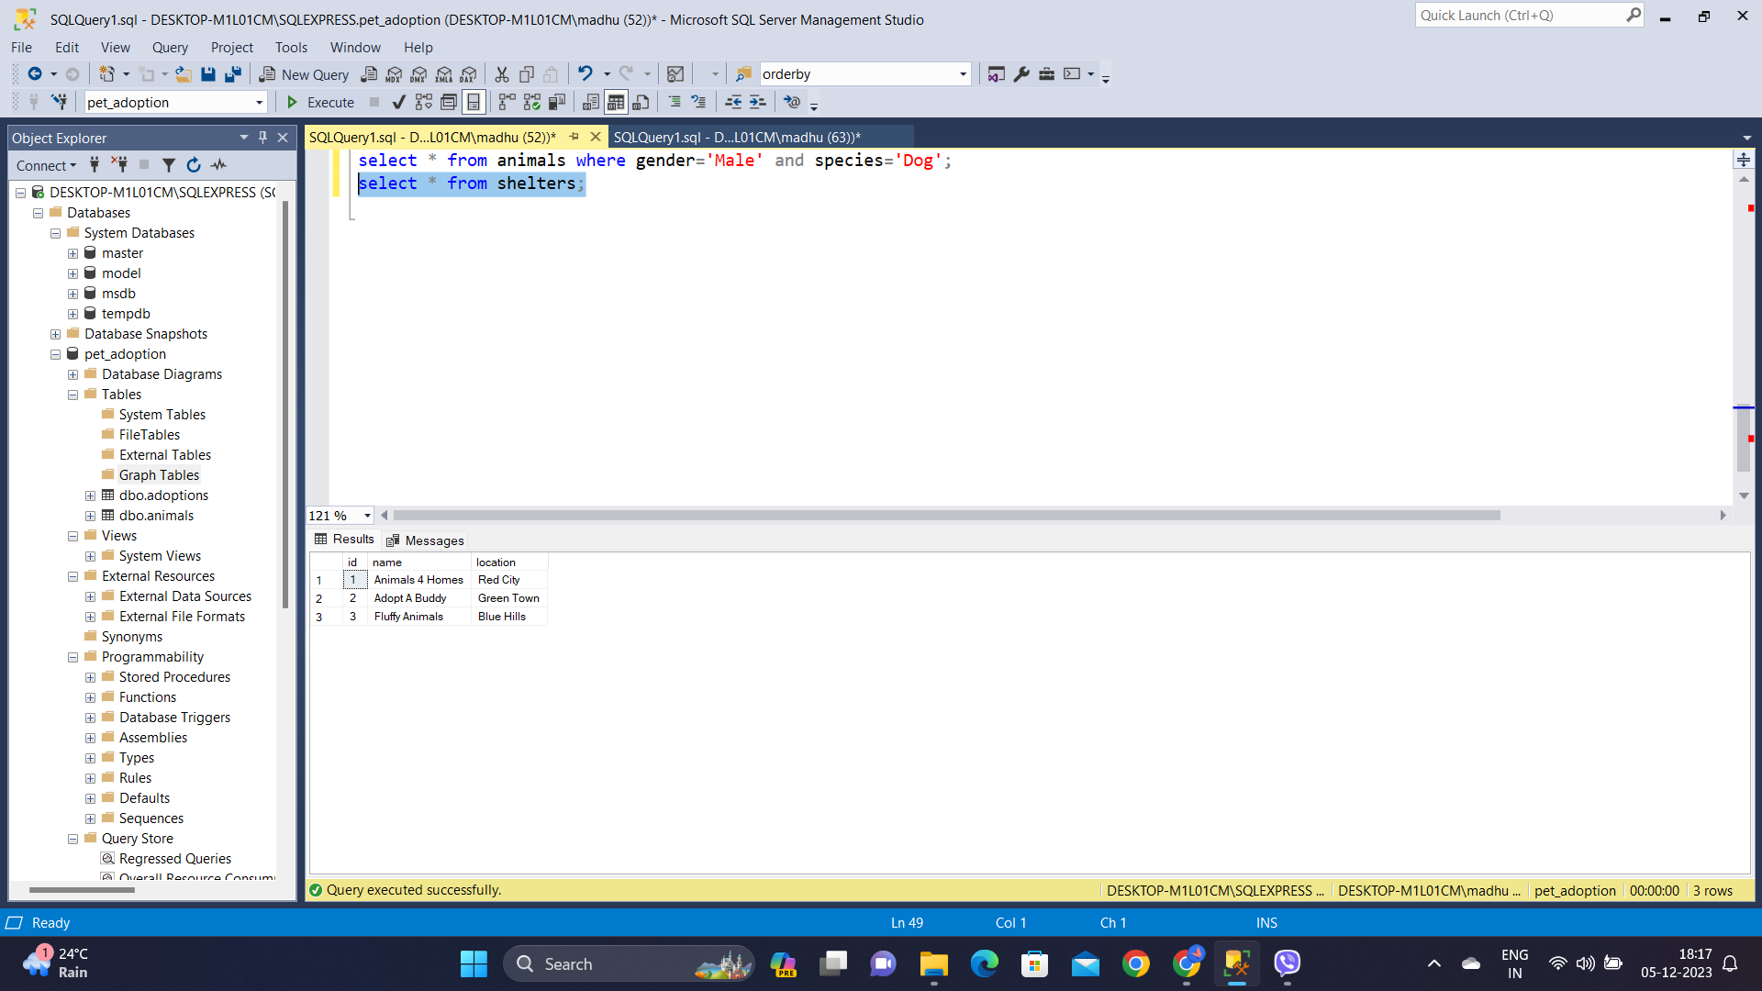  
  
To see all the data regarding an animal, it’s adoption status and the shelter of it without manually sorting we can use **joins** to get all the info needed in a table.

